**GIT Installation**

1. URL to download - <https://git-scm.com/downloads>
2. Download as per your operating System.

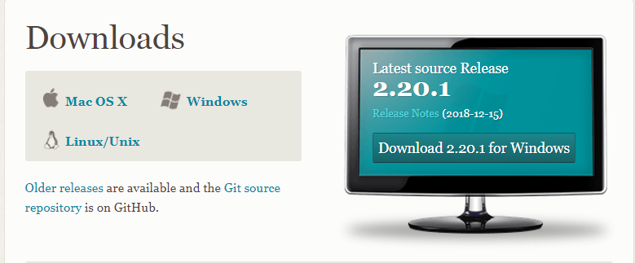

1. Run the Executable File

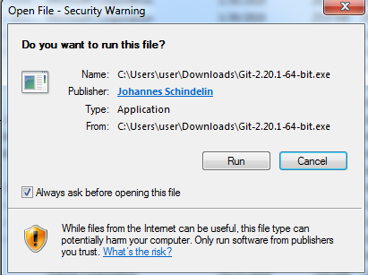

1. Click Next and Accept the License agreement.
2. Select Destination Location

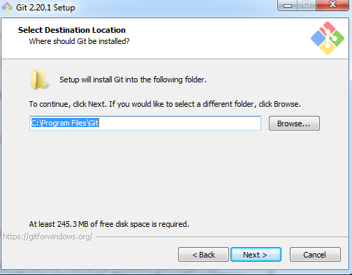

1. Select Components and click next

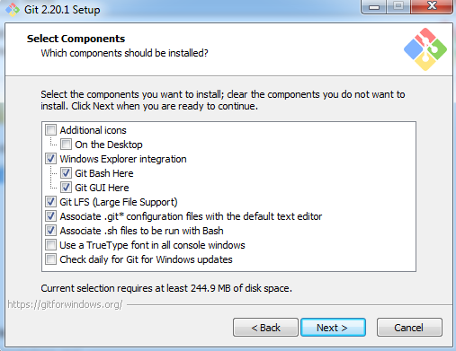

1. Select start Menu Folder

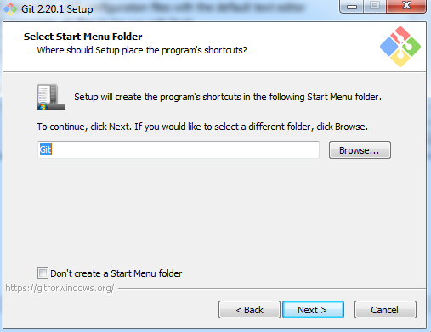

1. Choose the Default editor used by Git

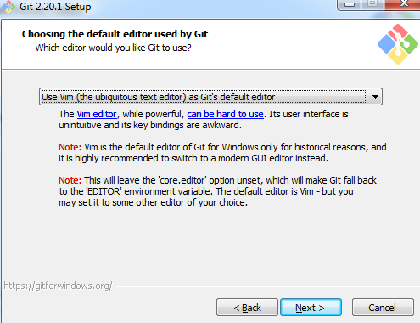

1. Adjusting your PATH Environment – **select the bottom option**

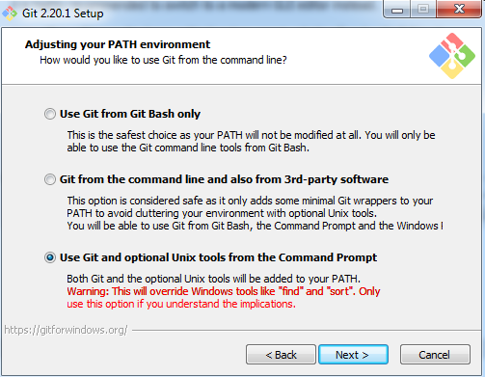

1. Choosing the SSH executable

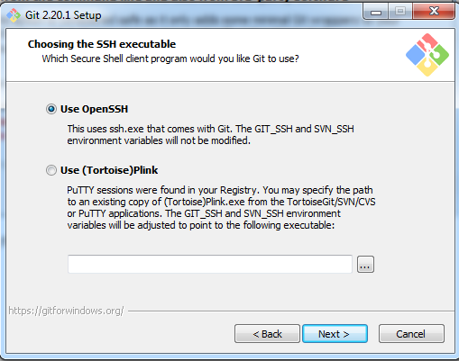

1. Choosing HTTPS transport backend

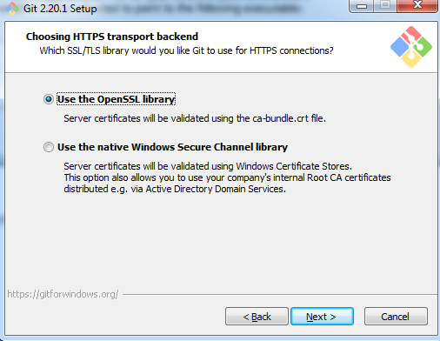

1. Configuring the line ending conversions

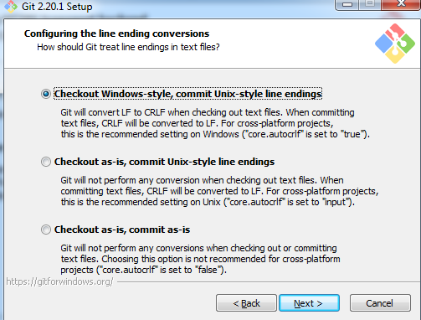

1. Configuring the terminal emulator to use with Git Bash

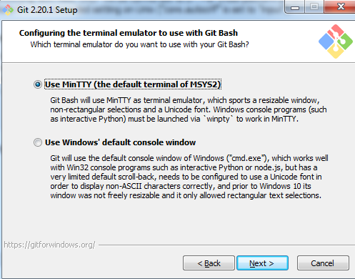

1. Configuring extra options and click Install

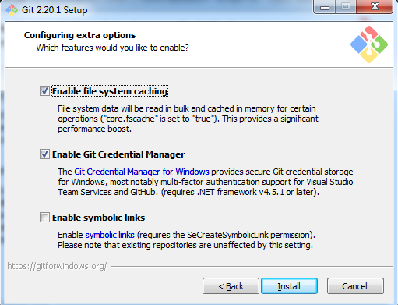

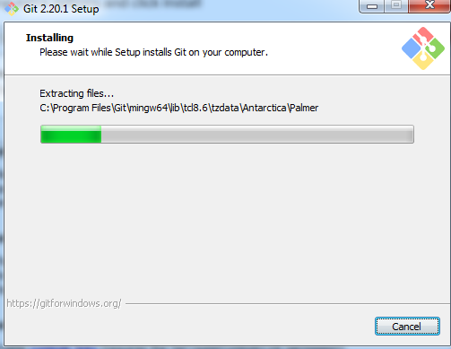

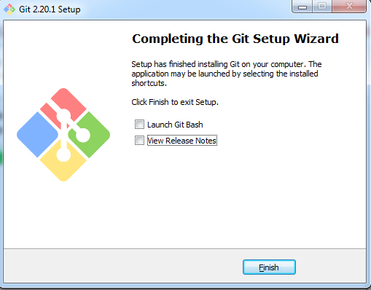

1. Sign in/Sign up https://github.com/